Zyxel troubleshooting:  
  
-To check the general information about the system [status]  
  
you will get the following information [model-firmware version-system status-interface status]  
  
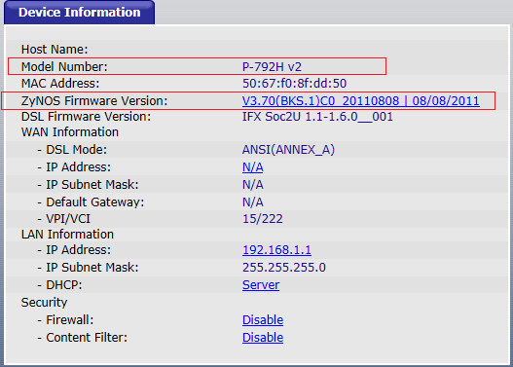  
  
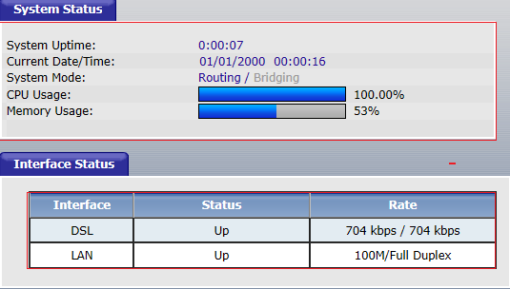

-to upgrade firmware [maintenance –tools- firmware]  
  
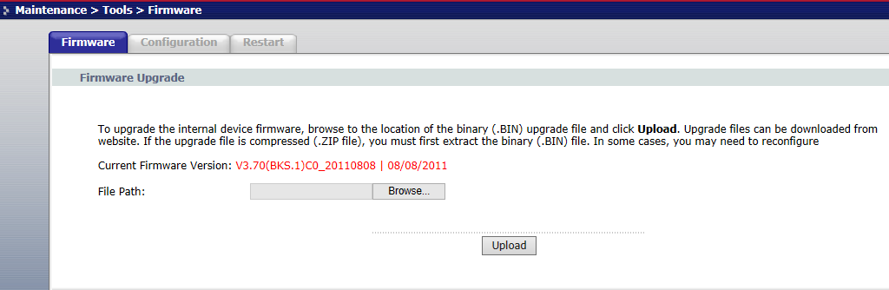

-to backup, restore configuration or set device to its factory setting [maintenance –tools-configuration]  
  
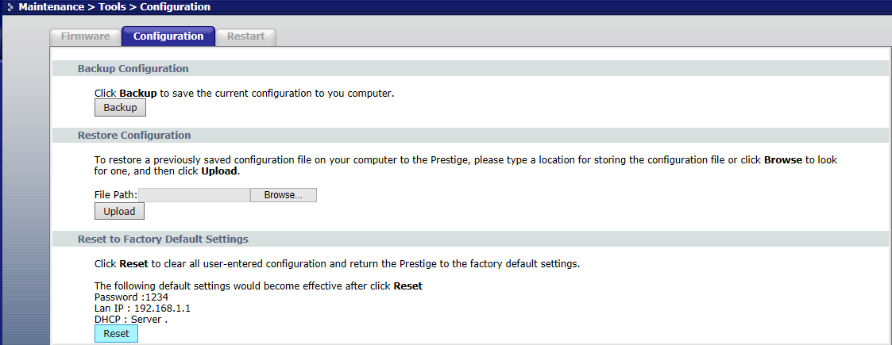

-to restart modem remotely [maintenance –tools-restart]  
  
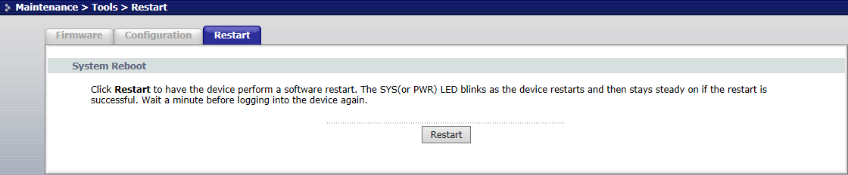  
-to check DSL margin and attenuation [maintenance –tools-diagnostic- DSL line]  
  
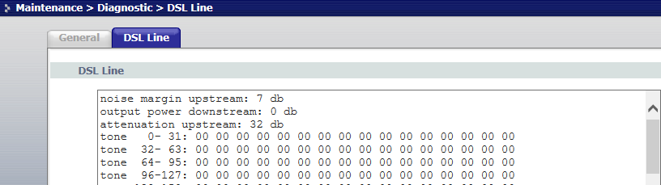  
-to change modem password [maintenance-system-general]   
  
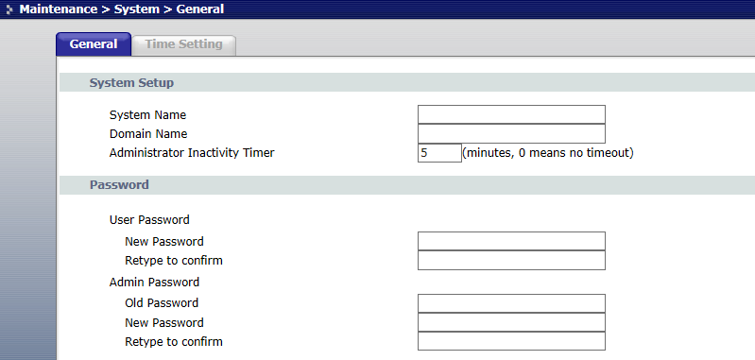  
to check modem's logs[maintenance-logs-view logs]  
  
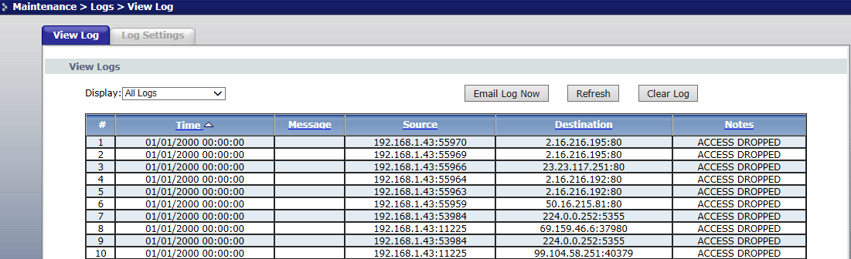

-to use ping utility[maintenance-diagnostic-general]  
  
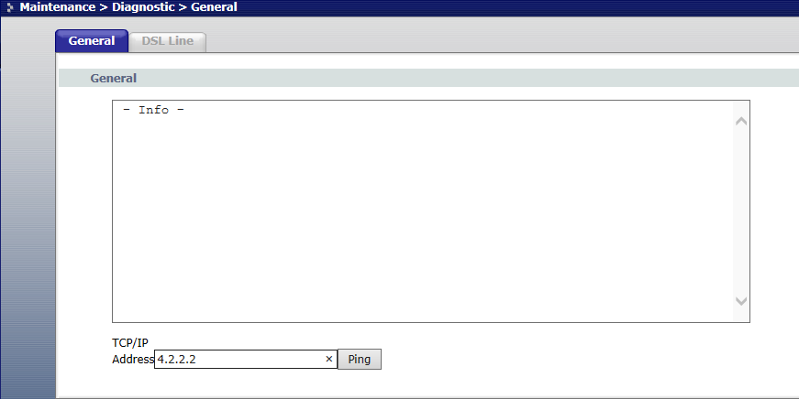

PartII- troubleshooting using command lines  
  
to access command line interface [system maintenance-command interpreter mode (24/8)]  
  
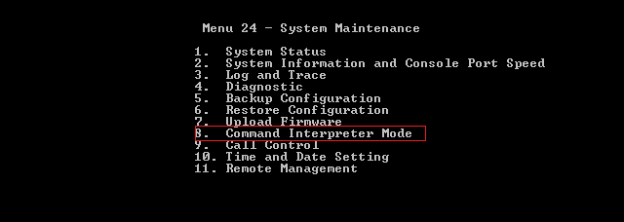

-to get the system uptime  
  
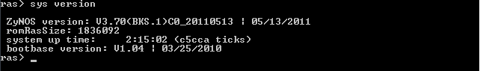

to check DSL status [system maintenance-system status(24/1)]  
  
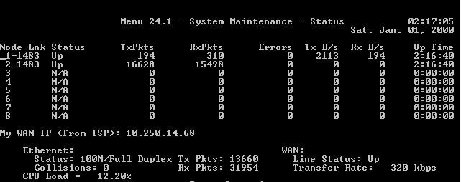

-To restart the modem remotely [system maintenance-Diagnostic (24/4/21)]  
  
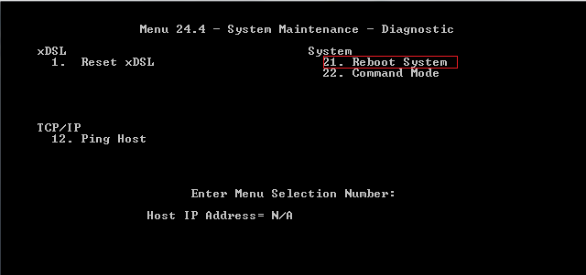  
  
 -to reset the modem to its factory setting  
  
  
  
-to show firmware version [system maintenance-system information –(24/2/1)] :  
  
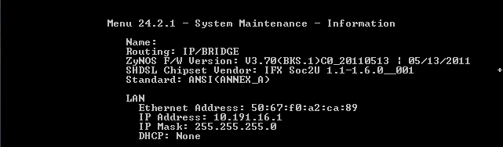  
  
-to allow remote management [system maintenance-remote management (24/11)]

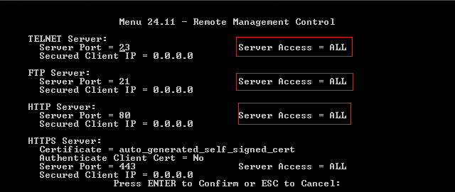

To check Ethernet status -  
  
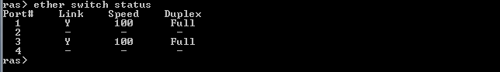  
  
-to check ARP table and clear entries:  
  
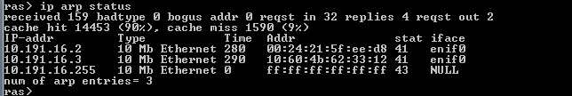  
  
  
  
-to use test tools:   
  
ping:  
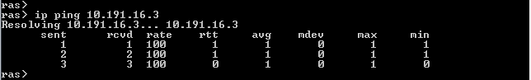

Extended ping:  
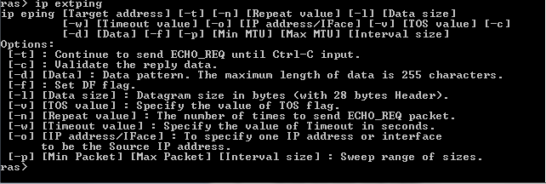

Traceroute:  
  
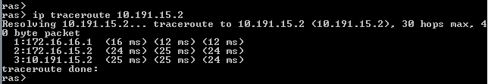

Telnet:  
  
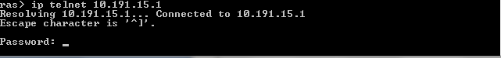

-to check routing table  
  
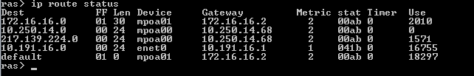

-to enable or disable 802.1Q  
  
1-use command [8021Q load]   
  
2-use command [8021Q disp] to know the current situation  
  
from the below, we can see that 8021Q is disabled  
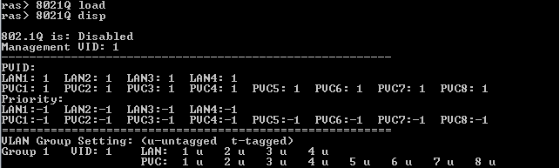

3-to activate 8021Q use the command 8021Q active [0: inactive 1:active ]  
  
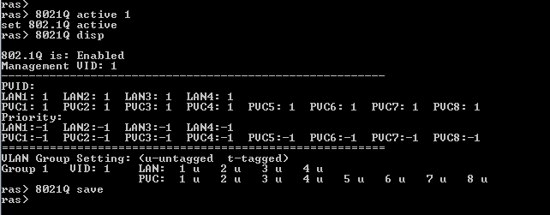  
  
4-use the command [8021Q save] to save the configuration.